Rahmat Enomoto (010).docx
by Turnitin

Submission date: 19-Jun-2024 05:25AM (UTC+0700)
Submission ID: 2403553007
File name: review_jurnal.docx (62.46K)
Word count: 1940
Character count: 13182

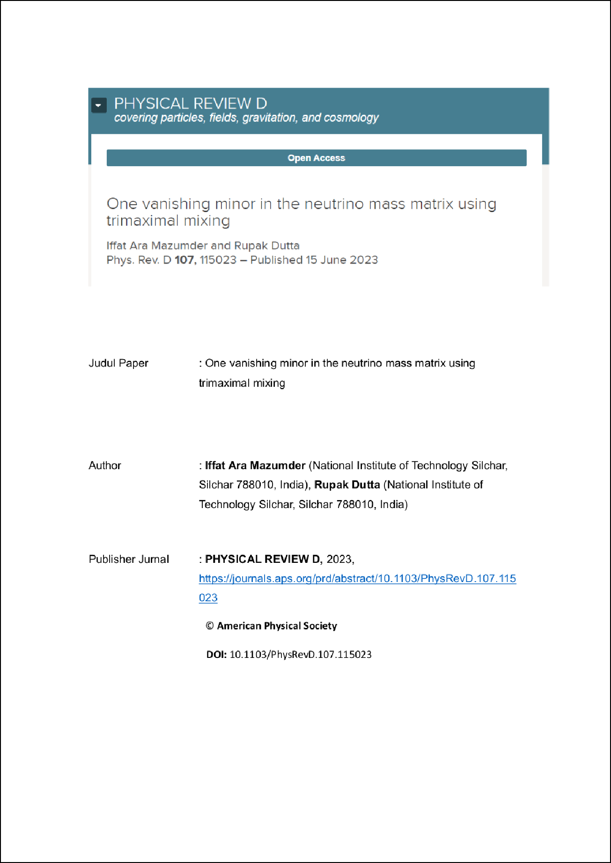

3

4

9

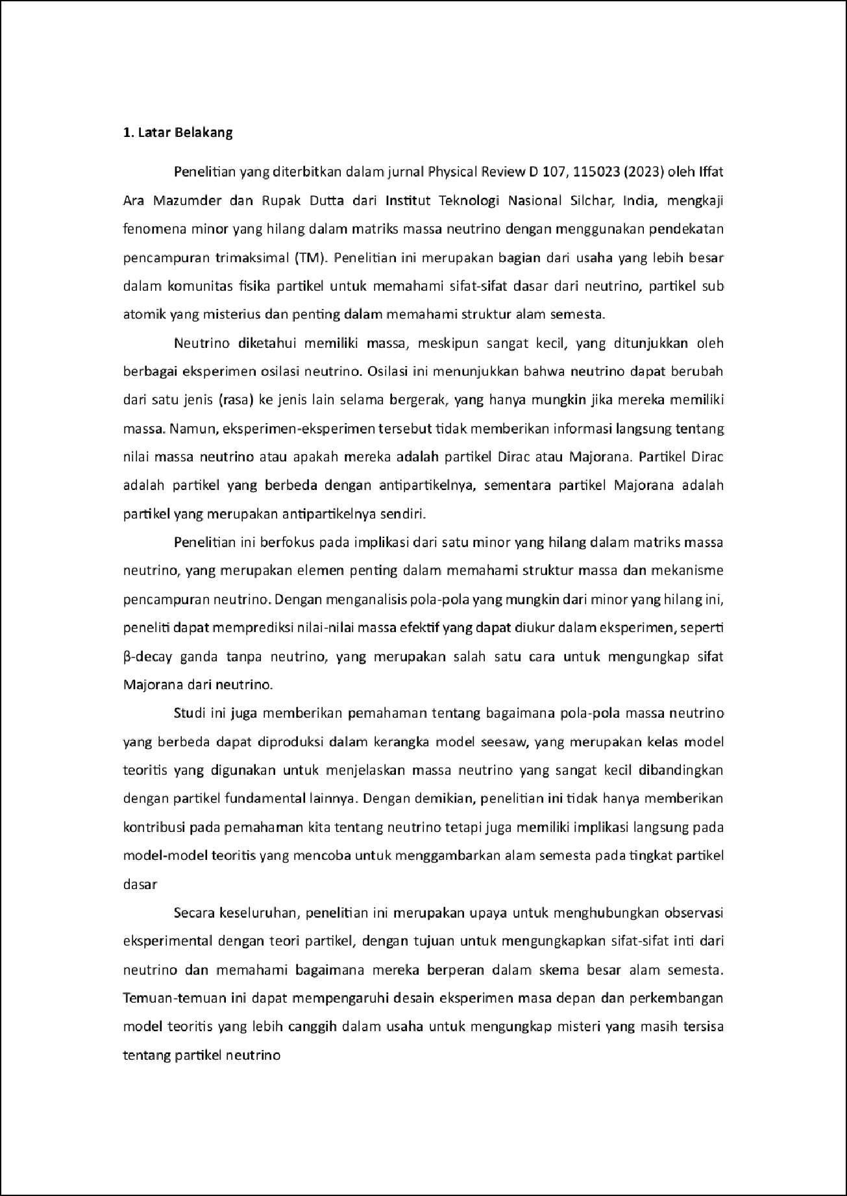

8

5

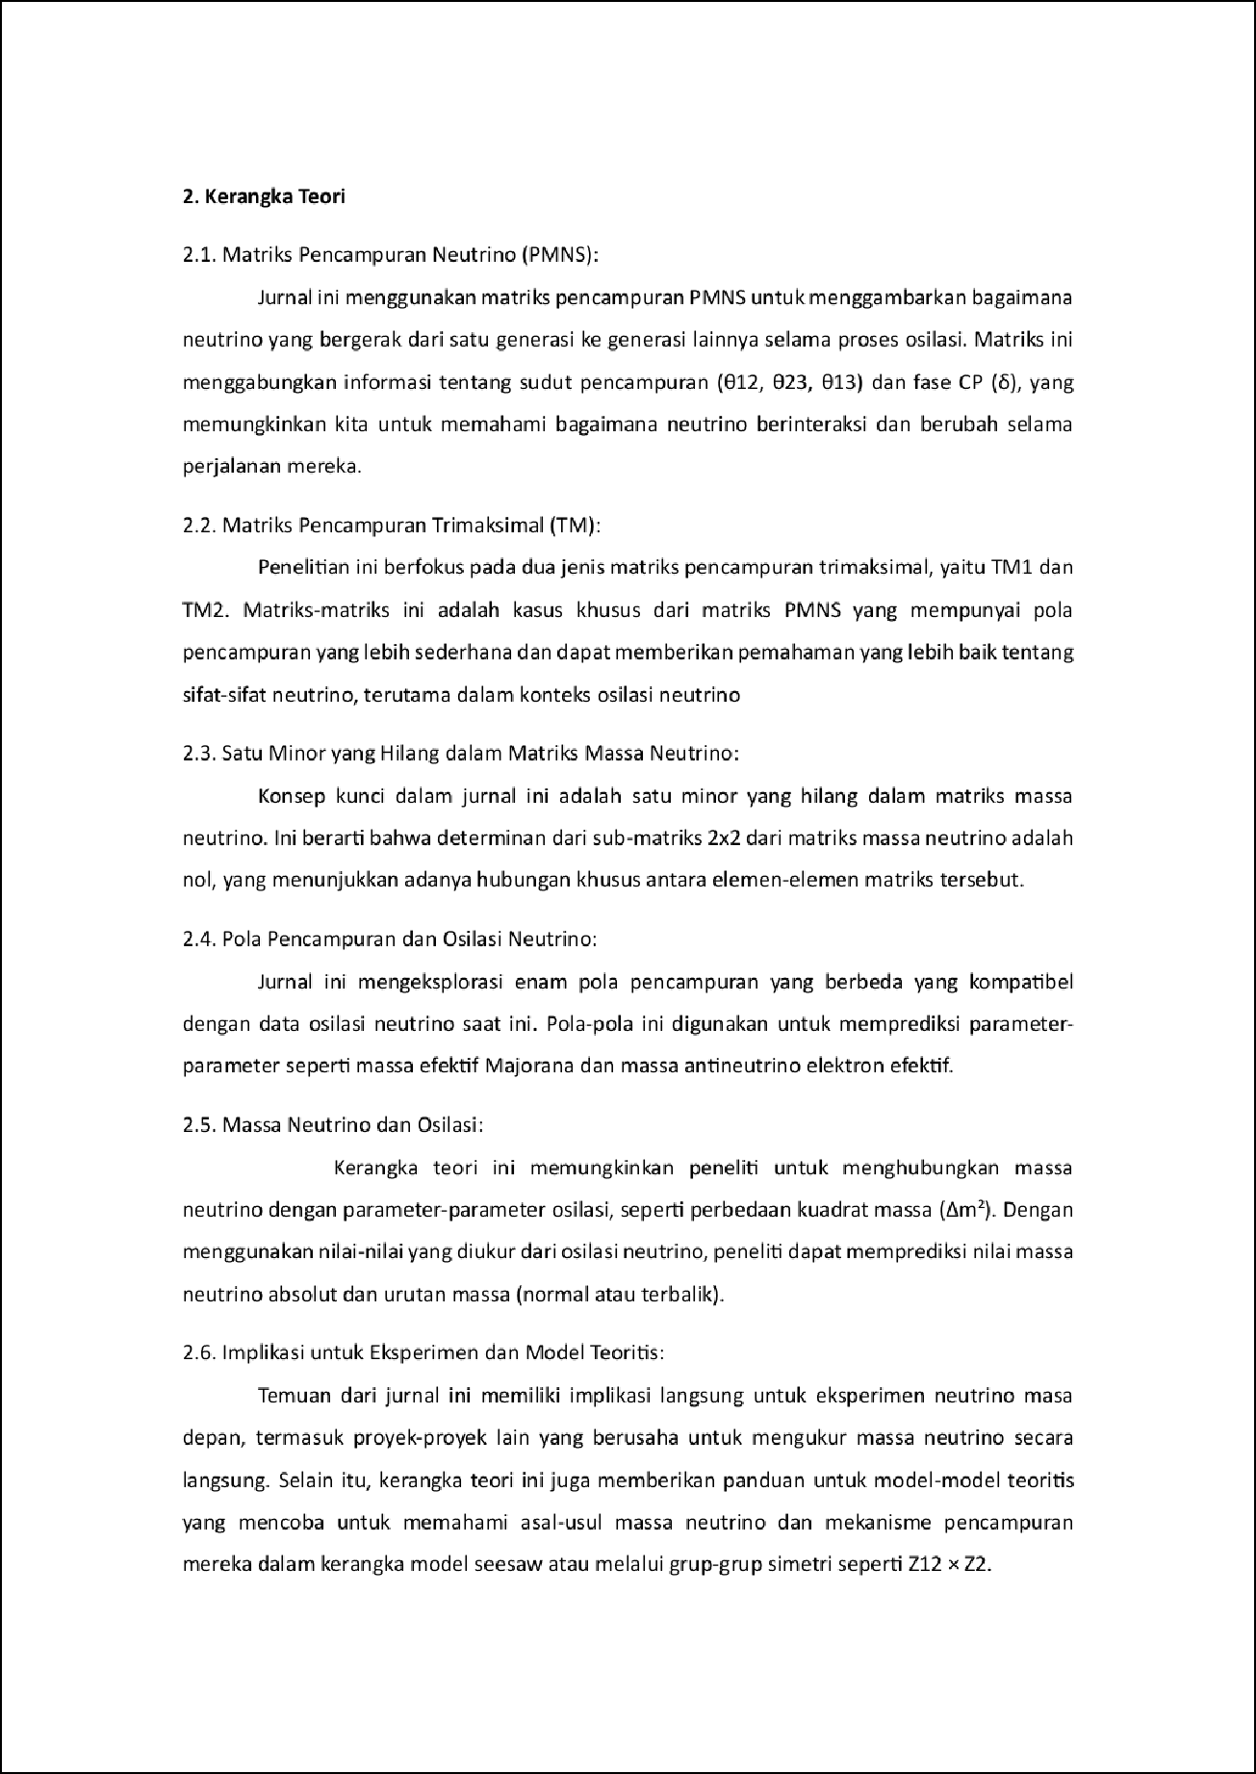

1

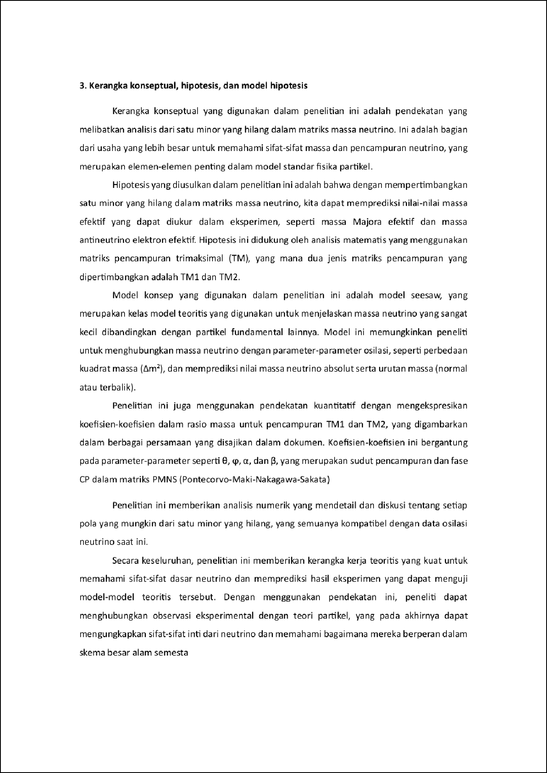

7

6

11

2

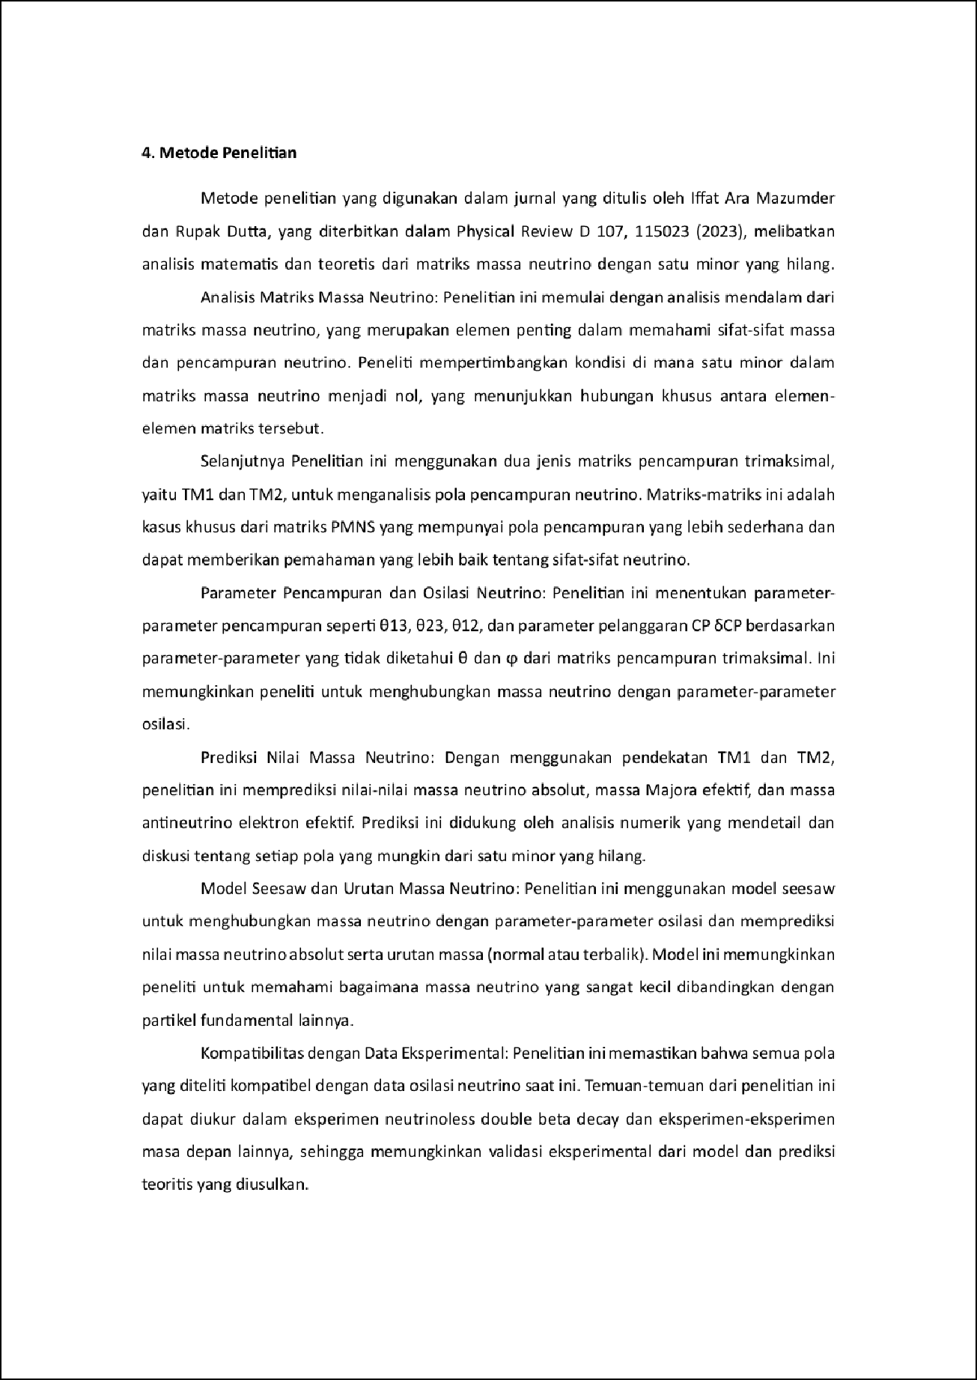

10

1

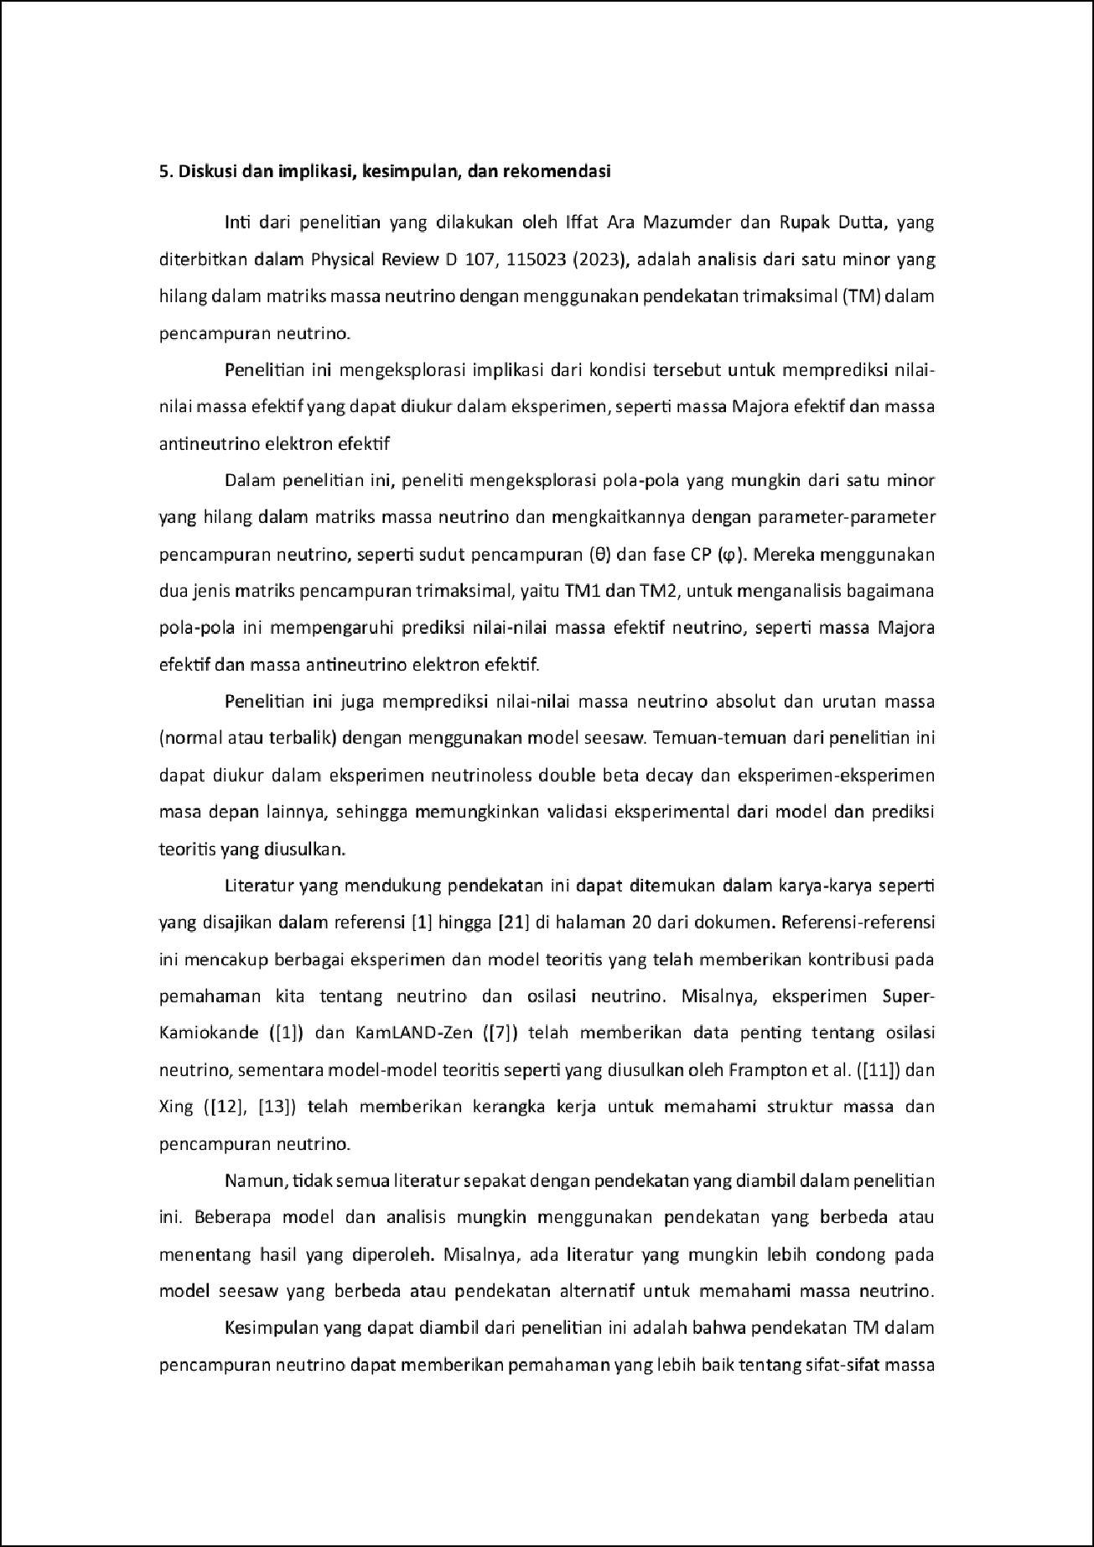

2

1

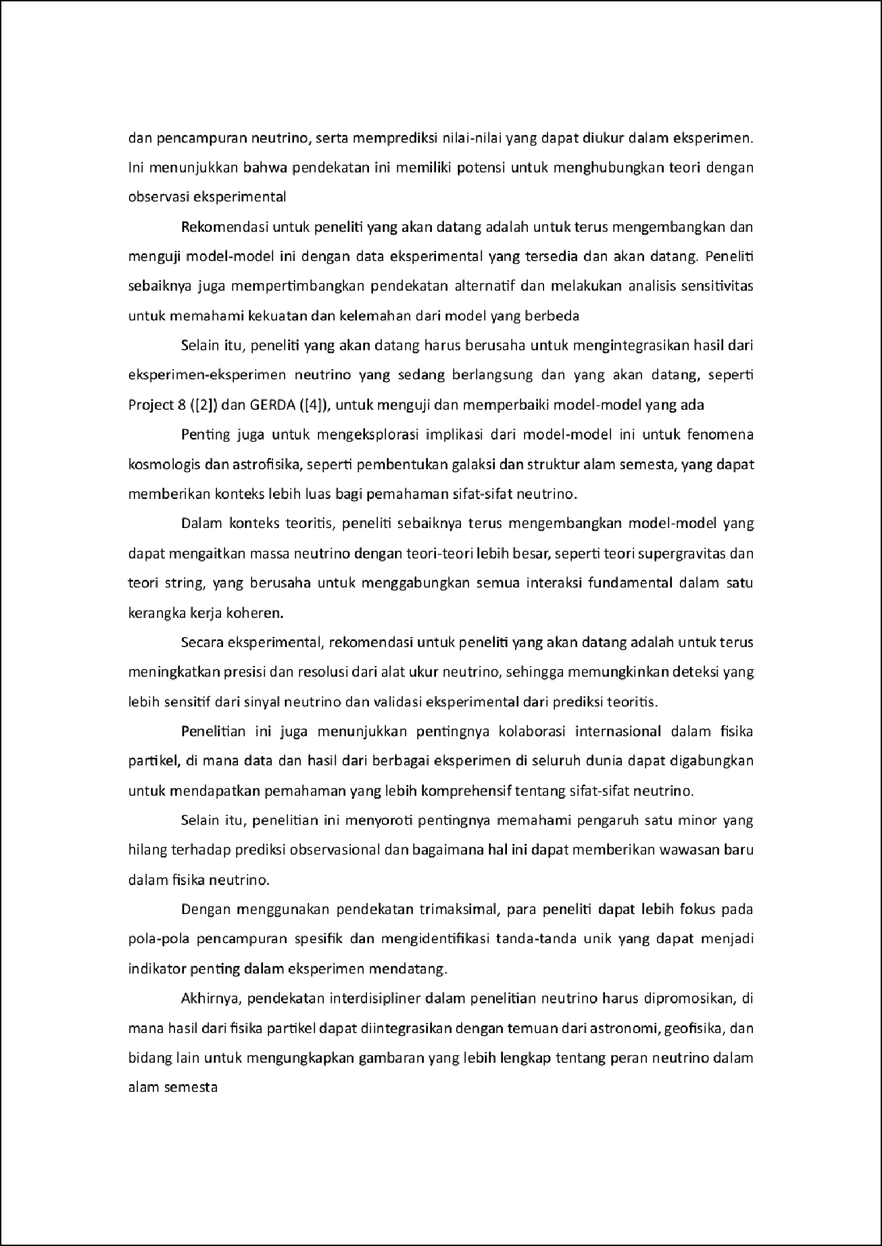



review jurnal.docx
7
ORIGINALITY REPORT

%
SIMILARITY INDEX
7%
INTERNET SOURCES
2%
PUBLICATIONS
1%
STUDENT PAPERS

PRIMARY SOURCES

rjaneeeee.wordpress.com
1
Internet Source

bahan-kuliahgratis.blogspot.com
2
Internet Source

3 Abhijit Barman, Rubi Das, Pijus Kanti De. "Optimal pricing and greening decision in a manufacturer retailer dual-channel supply chain", Materials Today: Proceedings, 2021
Publication

bsu.edu.az
4
Internet Source

ocs.unud.ac.id
5
Internet Source

www.timesindonesia.co.id
6
Internet Source

adoc.pub
7
Internet Source

al-poenya.blogspot.com
8
Internet Source
1%
1%
1%

1%
<1%
<1%
<1%
<1%

9

10

11
drmc.library.adelaide.edu.au
Internet Source

id.scribd.com
Internet Source

repository.uma.ac.id
Internet Source
<1%
<1%
<1%

Exclude quotes On Exclude bibliography On
Exclude matches Oﬀ

